Interview page 6

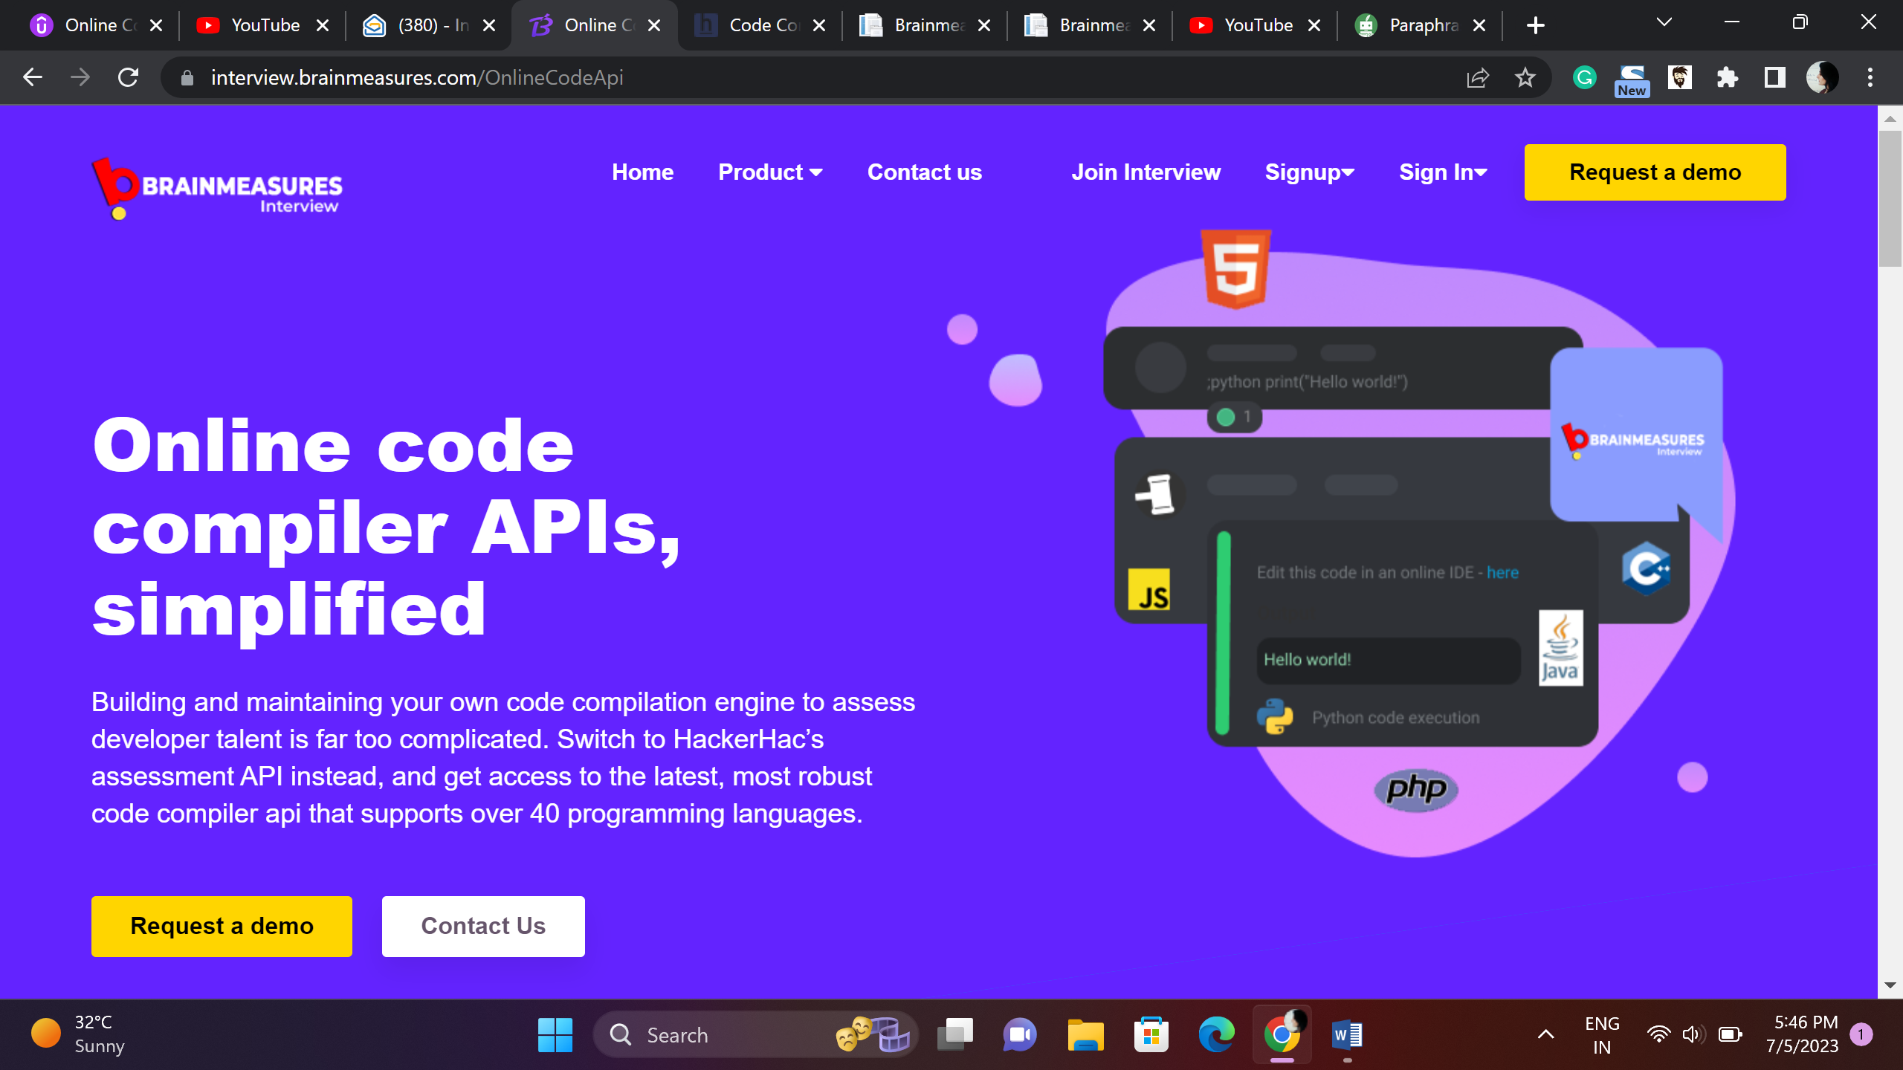

Experience Power of Code Compiler – Use Brainmeasures APIs

Use Brainmeasures Code compiler to elevate and upgrade your tech hiring experience, use Brainmeasures assessment APIs and use the power of technically advanced, enterprise grade code compiler that is loaded with robust features.

Request a demo Contact Us

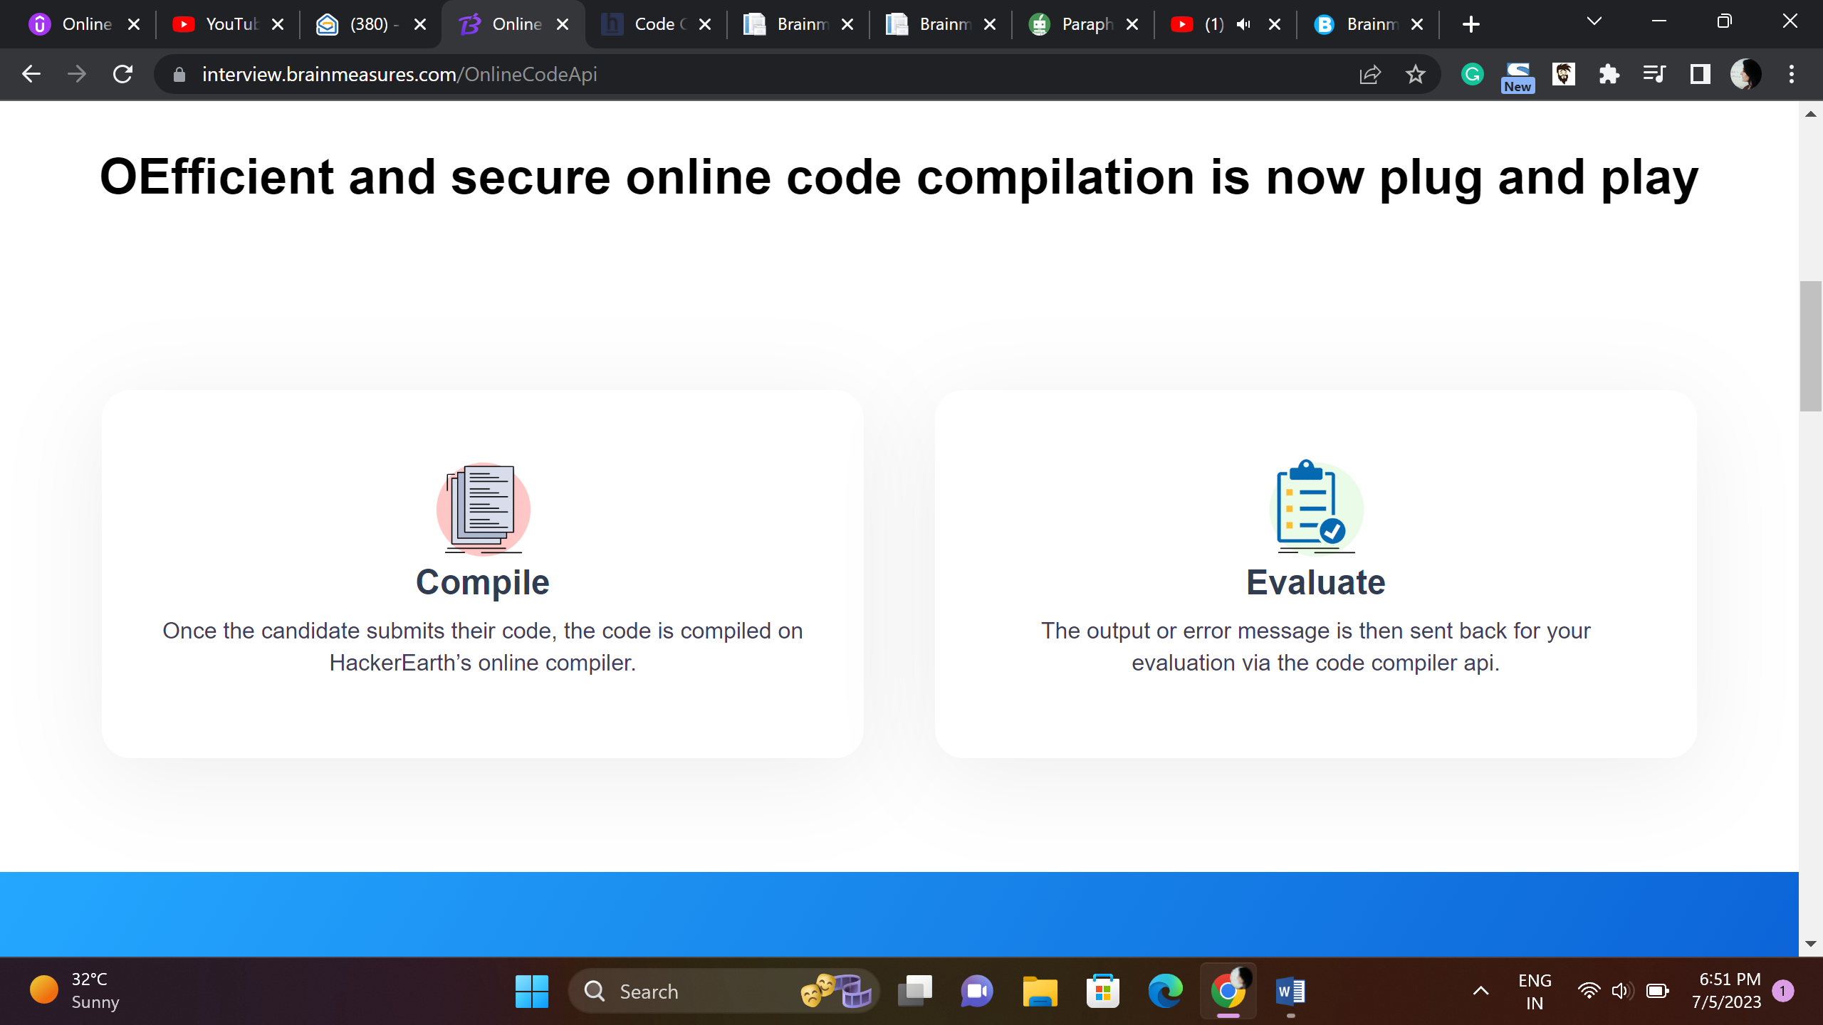

Brainmeasures Code compiler – Tech Hiring Simplified just Plug and Play

Online Compiler

Candidate writes the code and submits the code which is compiled online on Brainmeasures code compiler.

Evaluation

You can check the output sent to you through API exchange.

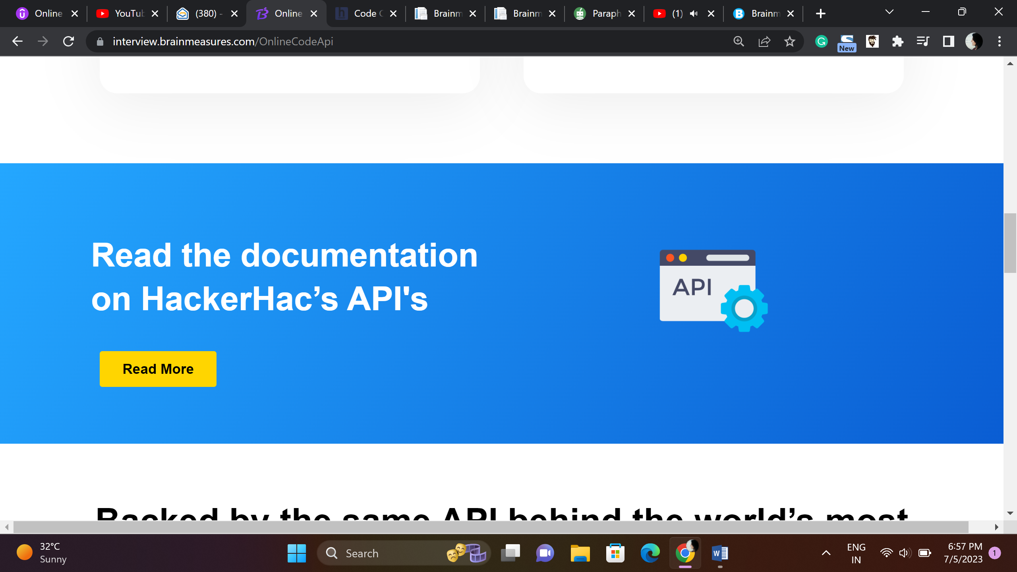

Brainmeasures API Documentation

Read more

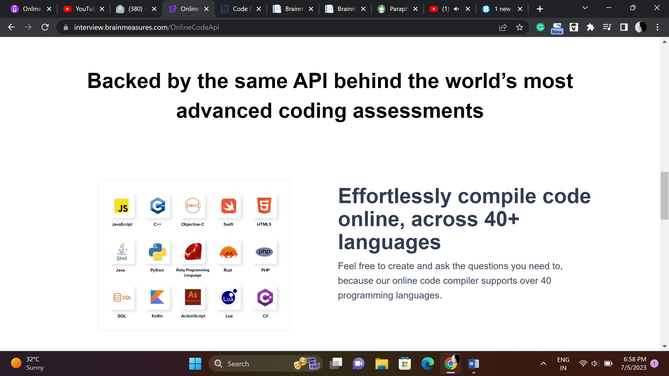

Globally Recognized Code Assessment Platform

Use Brainmeasures APIs and compile code in 50+ Languages.

Use Brainmeasures diverse code compiler and enjoy the freedom to create and ask questions you need to ask.

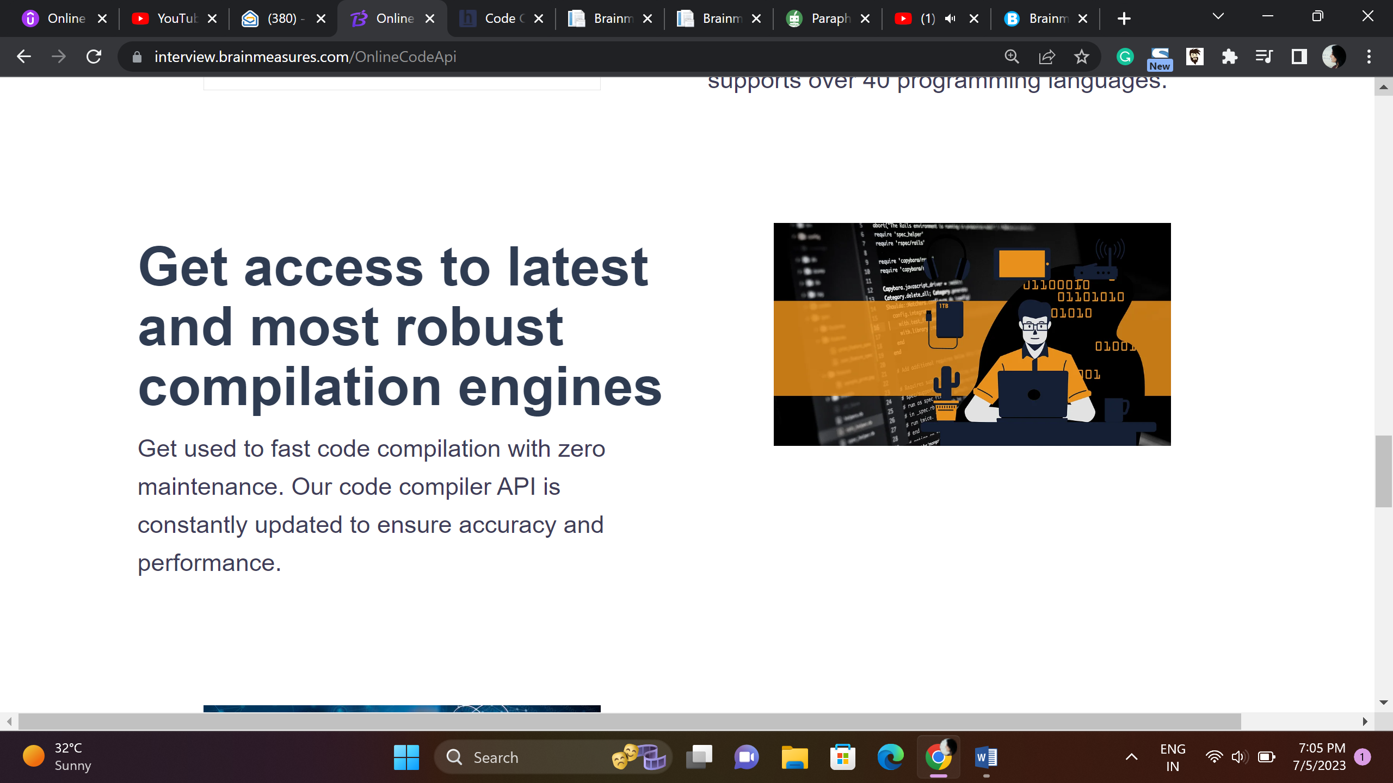

Brainmeasures API exchange empowers you to use advanced compilation engines

Brainmeasures code compiler is a robust and most advanced code compiler available, use the APIs and get access to zero maintenance coding engine.

Performance and Accuracy guaranteed.

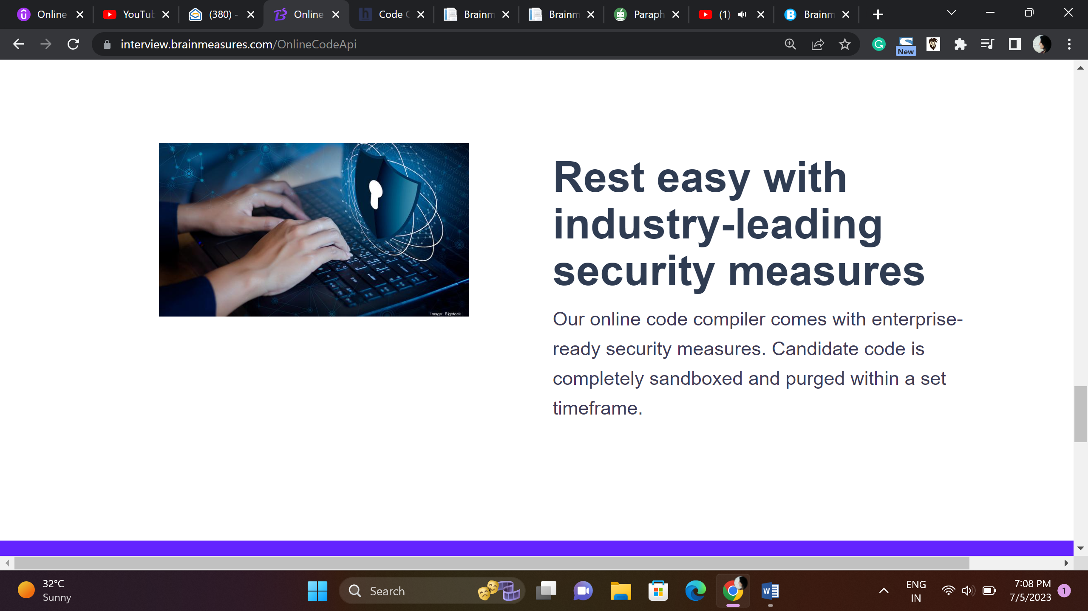

Secure and Trustworthy

Brainmeasures is an industry leading code compiler with enterprise ready security measures. Code submitted by candidates is purged and sandboxed in given timeframe.

